**Name:** Ahmed Atef Zakaria Ali

**B.N:** 78

**Date:** 30/5/2020

**Topic:** Operating Systems

Application Brief:

An operating system is the most important software that runs on a computer. It manages the computer's memory and processes, as well as all of its software and hardware. It also allows you to communicate with the computer without knowing how to speak the computer's language. Without an operating system, a computer is useless. And there are some types of operating system:

1-Batch operating system

2-Multitasking/Time sharing OS

3-Mltiprocessing OS

4-Real Time OS

5-Distributed OS

6-Network OS

7-Mobile OS

Screenshots:

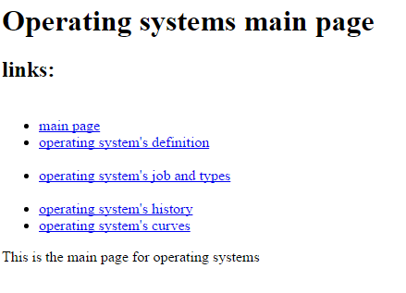

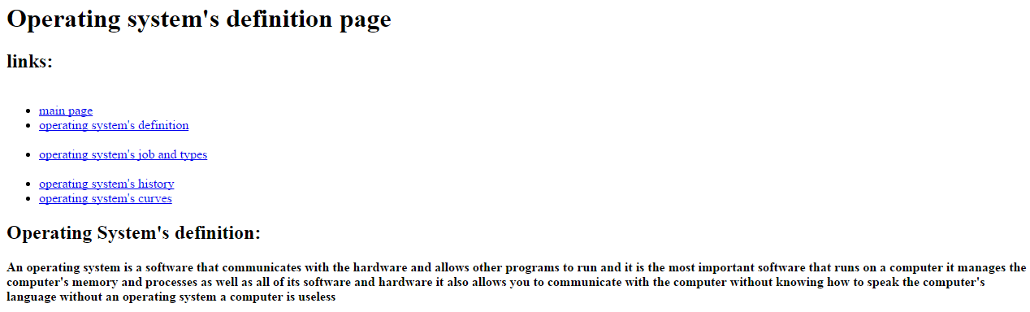

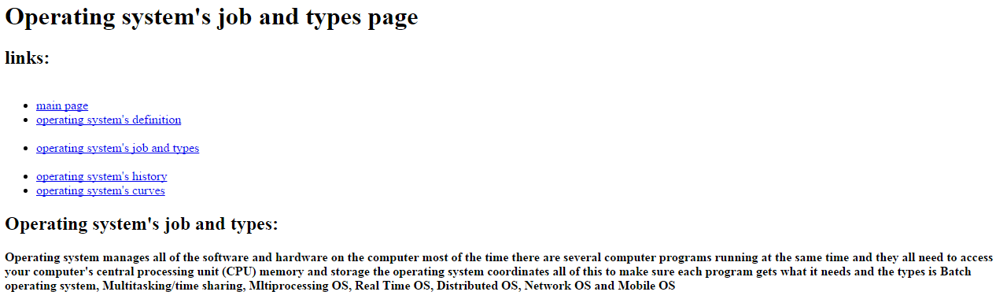

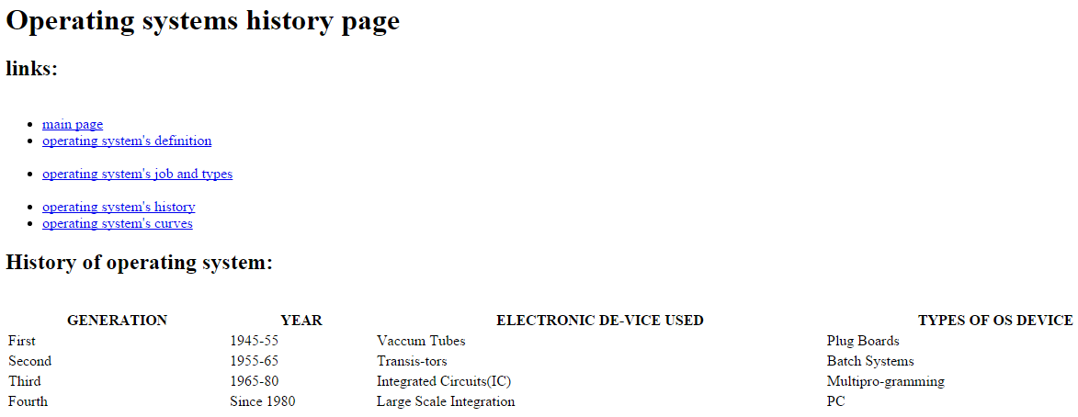

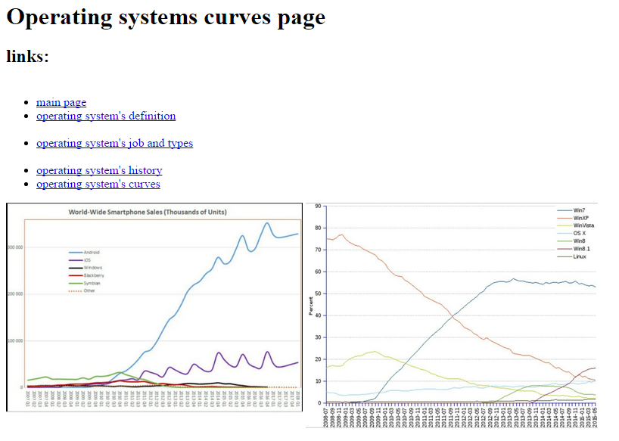

Source Code:

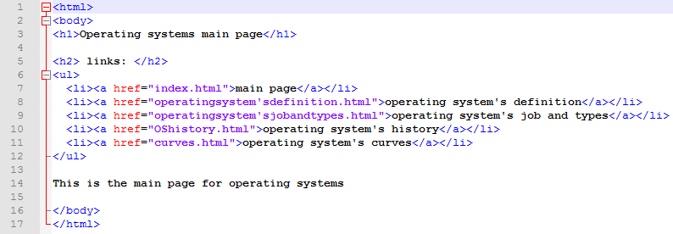

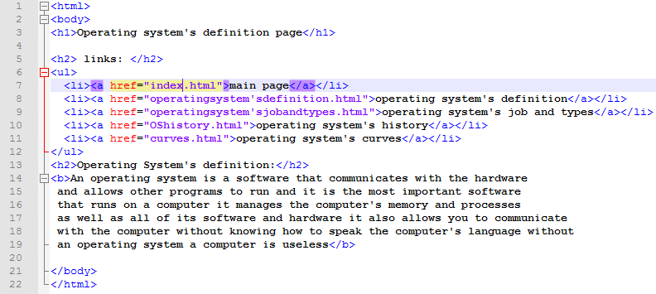

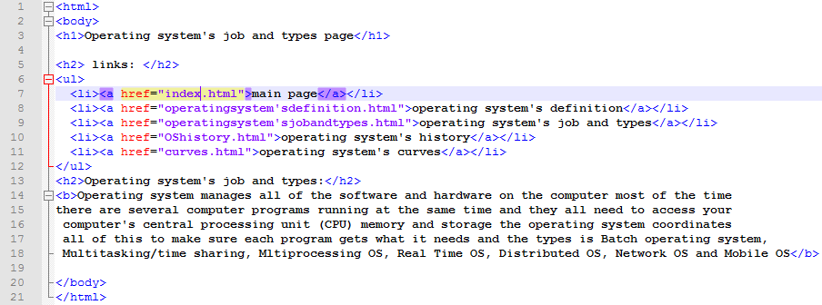

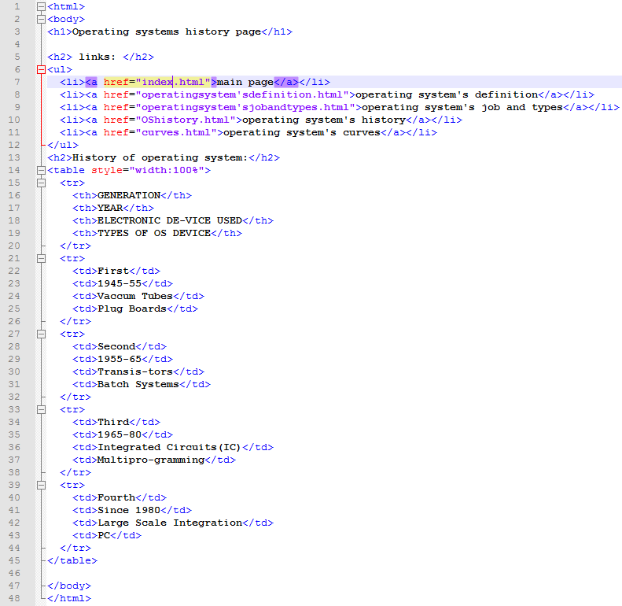

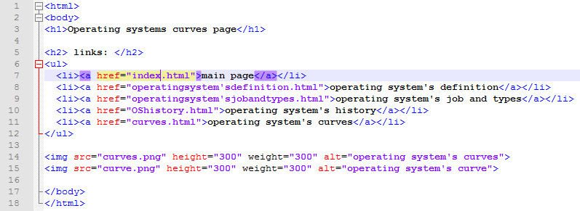

References

1-https://edu.gcfglobal.org/en/computerbasics/understanding-operating-systems/1/

2-https://www.guru99.com/operating-system-tutorial.html#6

3-https://www.lifewire.com/operating-systems-2625912

4-https://www.howtogeek.com/361572/what-is-an-operating-system/